**HTML Class 1**

* **Summary:**
* ***Structure:*** <> content </>
* Paragraph: <p></p>
* Bold: <b></b>
* Strong: <strong></strong>
* Italic: <i></i>
* Em: <em></em>
* Small: <small></small>

**Note:**

* Semantic means meaningful.
* Strong and em is semantic tags.

**Heading:**

* ***Structure:*** <h1></h1>

h1>h2>h3>h4>h5>h6

***Inline*** 🡪 in a line: strong, em, I , small, span

***Block*** 🡪 p, h(1-6), div

**List:**

List item 🡪 <li></li>

***Container tags:***

* Unordered list 🡪 <ul></ul>
* Ordered list 🡪 <ol></ol>
* Division 🡪 <div></div>

**List (ordered, unordered)**

* The <li> tag defines a list item.
* The <li> tag is used inside ordered lists(<ol>) and unordered lists(<ul>).
* In <ul>, the list items will usually be displayed with bullet points.
* In <ol>, the list items will usually be displayed with numbers or letters.

**Note:**

* **<br>** tag is used for breaking a para or a line.
* Button 🡪 <button></button>

**Anchor tag:**

* ***Structure:*** <a></a>

But it is not work without hypertext reference.

* Hypertext reference 🡪 href
* Final structure 🡪 <a href=”link”>name</a>
* Opening in new tab 🡪 <a href=”link” target=”_blank”>name</a>

***Example:*** <a href=<https://www.google.com>>Google</a>

**Image tag:**

* Void tag: <img></img>
* Self-closing tag: <img/>
* ***Structure:*** <img src=”” alt””>

1. ***Image from internet:***

<img src=”image link from internet”>

1. ***Image from local folder:***

<img src=”image location” alt=”alternative name”>

*Image: img, Source: src*

**Form:**

* ***Structure****:*

***<input type=”” name=”” id=””>***

***Example:***

<form>

<input type=”email” placeholder=”Your Email” name=”” id=””>

<br>

<input type=”password” placeholder=”Your Password” name=”” id=””>

<br>

<input type=”submit” value=”Login”>

</form>

**Ordered list type:**

* Type=”1”
* Type=”a”, Type=”A”
* Type=”i”, Type=”I”

**Unordered list type:**

* Type=”disc”
* Type=”circle”
* Type=”square”
* Type=”none”

**Select:**

<select name=”” id=””>

<option value=””></option>

<option value=””></option>

<option value=””></option>

<option value=””></option>

</select>

**HTML Input Types:**

Here are the different input types you can use in HTML:

* <input type="button">
* <input type="checkbox">
* <input type="color">
* <input type="date">
* <input type="datetime-local">
* <input type="email">
* <input type="file">
* <input type="hidden">
* <input type="image">
* <input type="month">
* <input type="number">
* <input type="password">
* <input type="radio">
* <input type="range">
* <input type="reset">
* <input type="search">
* <input type="submit">
* <input type="tel">
* <input type="text">
* <input type="time">
* <input type="url">
* <input type="week">

**Tip:** The default value of the type attribute is "text"s

**HTML Structure:**

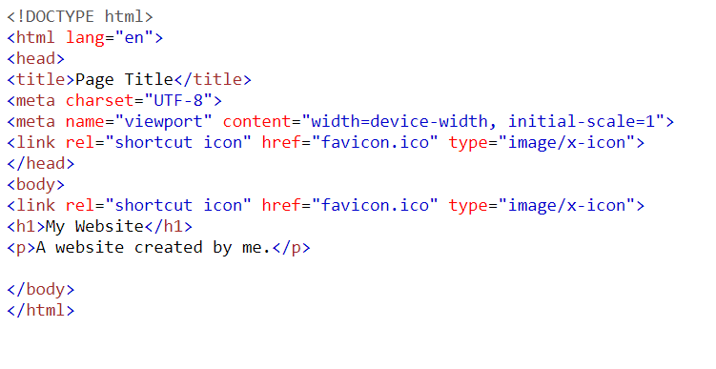

**Comment tag:**

* ***Structure:***

<!-- comment -->

**Example:**

